English Course User Guide

Team 5

Team Members
Giacomo Lorenzi
Matteo Olivieri
Robert Alex Ramascanu
Luigi Ianni
Emanuele Maccacaro

Contents

Contents 2
1 Introduction 3
2 Quick Start Guide 3
3 System Requirements 5
4 Main Scenarios of Use 5
5 Troubleshooting 6

Introduction
The Moodle platform has given the possibility to our team to create an English course in a very short time, precisely because it is an IT environment for course management. Project constraints will be included in separate documentation. The Software Project Management Plan will give specifics on project budget and schedule. A separate Test Plan document will address test specifications and procedures.

Quick Start Guide
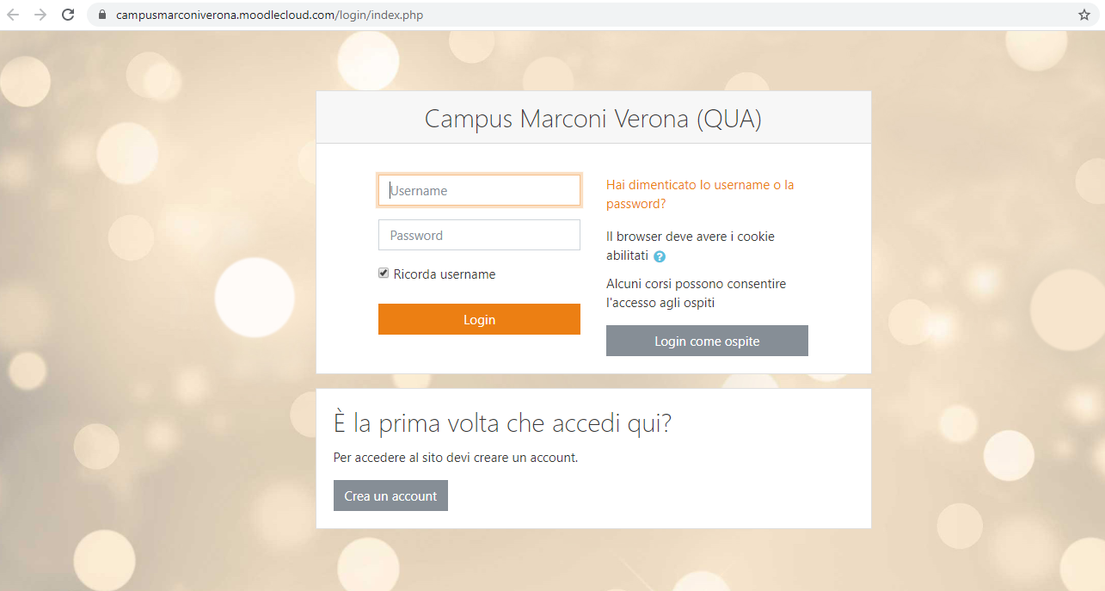
- The login screen will be brought up.

- Enter your E-Mail and Password.
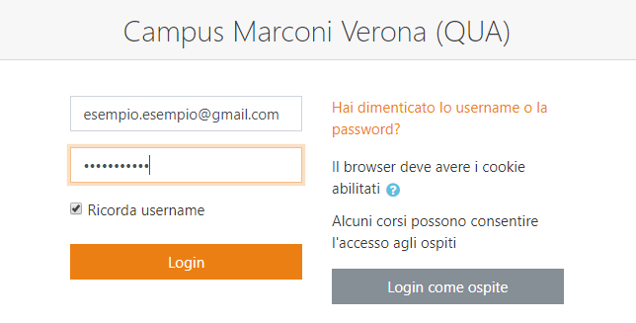
- Tap the Login button.
- The English Couse will be displayed.
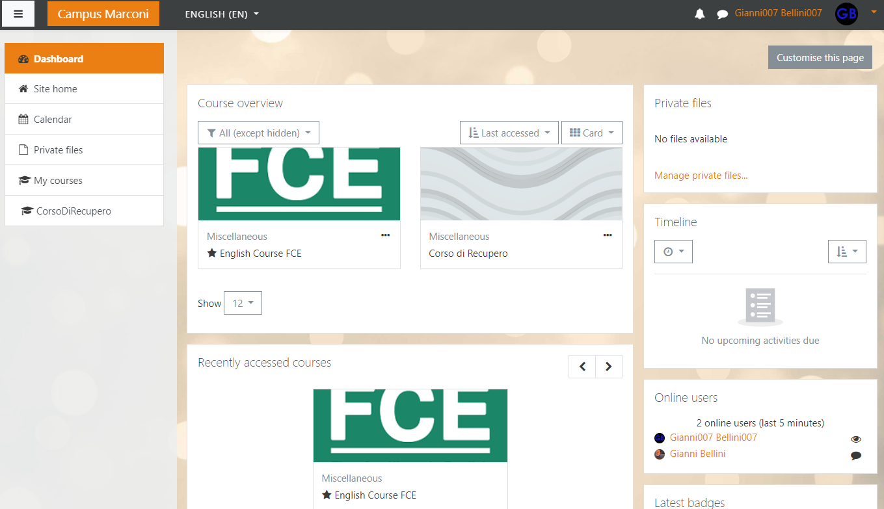

System Requirements
To run this course is needed a simple web browser. The platform is online so there is no need of high performance hardware on the user pc.

Main Scenarios of Use

View English Course
- Tap the English Course FCE in your homepage.
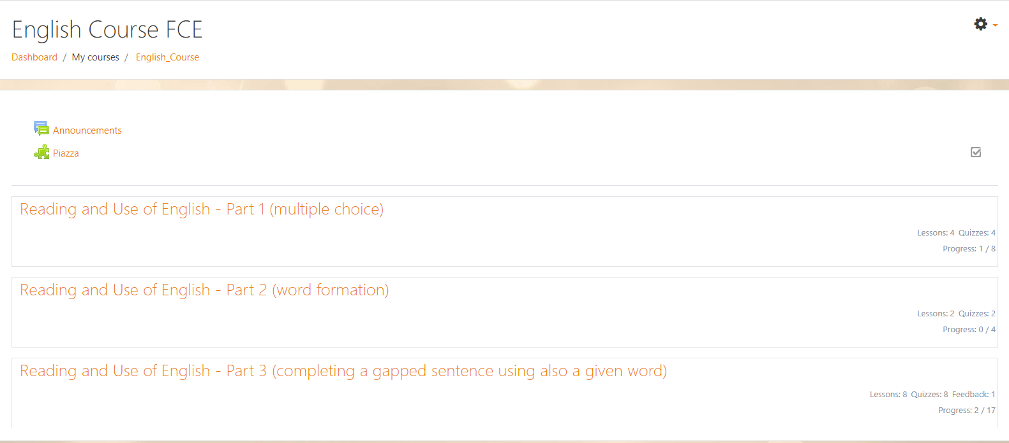
- Choose one of the following courses you want to do.
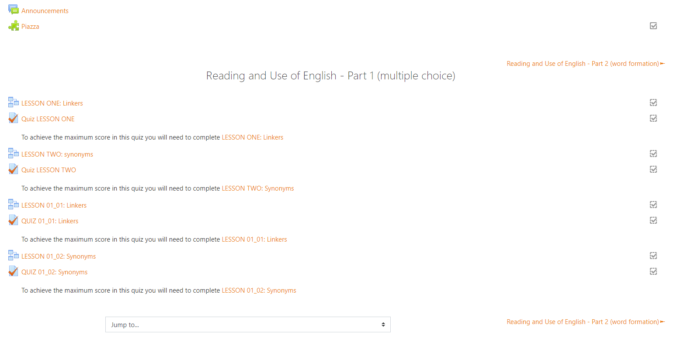
- Now you can start the LESSON ONE.

Troubleshooting

Missing or Incorrect Password or E-Mail
A message will be displayed in the event incorrect login information is entered. Try again with proper credentials to access. If trouble is encountered, retrieve proper login information directly.
